Software Requirements Specification

Weather Website/Application

Version 2.0

Tyerra Smith

Olivia Horace

Gavin Kerr

Table of Contents

1. Introduction

1.1 Purpose

1.2 Scope

1.3 Definitions, Acronyms, and Abbreviations

1.4 References

1.5 Overview

2. Overall Description

2.1 Product functions

2.2 Constraints

2.3 Assumptions and dependencies

2.4 Apportioning of Requirements

3. Specific Requirements

3.1 Interfaces

3.2 Functional Requirements

3.3 Performance Requirements

3.4 Design constraints

4. Prioritization and Release Plan

4.1 Choice of Prioritization Method

5. Appendices

5.1 Appendix I

5.2 Appendix II

1. Introduction

This section of the Software Requirements Specification (SRS) will include a detailed explanation of the purpose and scope of this project. In addition, important definitions, acronyms and abbreviations will be provided, as well as, a list of references and a brief overview of the contents in the remainder of this document.

1.1 Purpose

The purpose of this Software Requirements Specification (SRS) is to provide a detailed explanation of the requirements for the “Weather Website/Desktop Application”. The SRS will give a detailed account of what the purpose of this project is, the scope of the project, and important information that will allow the users and consumers to better understand the “Weather Website/Desktop Application” as a whole.

1.2 Scope

The “Weather Website/Desktop Application” will, as the project’s name implies, be either a website or a desktop application. We will begin by creating the website version of the project. This website serves the purpose of allowing visitors of the site to view weather conditions of a location that can be specified by a city and state pair. Once the location is validated, possible information displays include: current conditions, 3-day forecast, astronomy, geolookup, and almanac .

1.3 Definitions, Acronyms, and Abbreviations

API - Application programming interface

* Set of definitions and tools used in building application software

SRS - Software Requirements Specification

* A document outlining the requirements and expectations of a software application

App - Application

* A program designed to complete a specific task

CSS - Cascading Style Sheets

* Used in conjunction with HTML, Hypertext Markup Language, to format web pages

HTML - Hypertext Markup Language

* Language used to create and design web pages

Bootstrap

* Used to design web pages so that the pages will be properly displayed based on the dimensions of the browser used to view them

Browser

* Application used to access websites

Linux

* A free computer operating system

Windows

* A computer operating system created by Microsoft

iOS

* An operating system created by Apple and ran on Mac

1.4 References

[1] “API Documentation.” *Weather Underground*, TWC Product and Technology LLC, 2018, [www.wunderground.com/weather/api/d/docs](http://www.wunderground.com/weather/api/d/docs).

1.5 Overview

The subsequent sections of this document will provide pertinent information and will provide a detailed description of the Weather Web App project. Section two will provide a explanation of the Weather Web Applications interaction with other systems. Section 3 will explain the specifics of the Weather Web Application. Section 4 will express the development team’s release and prioritization plan. Lastly, Section 5 will be composed of all appendices(if any) and supporting information.

2. Overall Description

This section of the Software Requirement Specifications (SRS) will give the specific details of how the project will interact with other systems. The functionality of this project and the prospective users of this project along with the constraints and assumptions of the project.

2.1 Product Functions

The product will function as a weather data collection that can be accessed through an internet browser allowing individuals to view information on weather conditions given location data as input. Following the authentication of the input data, desired weather data containing forecast information and recent conditions will be displayed on the page for user consumption.

2.2 Constraints

The API, which will be used to access the weather data, puts restrictions on what data can be accessed and how often. The application will have to take into account the number of calls being made in a given time period in order to not exceed the enforced limit. Additionally, the accuracy of the data will be questionable at any given time as the most recent corrections will not be accessible by this application through the API.

2.3 Dependencies and Assumptions

It is assumed that this Weather Web application will be ran on an internet browser. It can be viewed from within: Edge, Mozilla, Firefox and Safari browsers. The computer used to access this Weather Web application should have internet connection.

2.4 Apportioning of Requirements

The browsers, as well as the required specifications of said browsers, necessary to view and use this application may change with updates to the Weather Web Application.

3. Specific Requirements

This section of the Software Requirement Specifications (SRS) will include a breakdown of the interfaces and functional necessities required in order for this project to perform properly.

3.1 Interfaces

The interface will allow a standard web application to be accessed and run on modern web browsers. The site will be optimized for user input and data output. Input options will take the form of correctly labeled text forms which give individuals multiple methods for location choice. There will also be an interactive map that will display an overhead view of the selected location with an overlay of pertinent information.

3.2 Functional Requirements

This section will list and give a brief description of the functional requirements of the Weather Web Application.

3.2.1 The web application should allow the user to input a city’s name and state’s abbreviation that when combined create a valid city, state pair that corresponds to the location of which the user would like to view weather information.

3.2.2 The weather application should allow the user to select one of five weather information options: current conditions, geolookup, three-day forecast, astronomy, or almanac.

3.2.3 The web application should have a submit button that allows the user’s input to be delivered to the backend.

3.2.4 The web application should, once user input has been validated, the display option has been selected and the submit button has been clicked, display the weather information that corresponds to the user input and the display option selected.

3.2.5 The web application should use autocorrect to ensure that the user input is formatted correctly.

3.2.6 The web application should, once user input has been validated, display an interactive google map for that location.

3.3 Performance Requirements

The web application should be access from a computer running either a Linux, Windows, or iOS operating system. There are time constraints for requesting weather data which will prevent the user from making requests that may potentially exceed the API limit.

3.4 Design Constraints

The design of the website will follow CSS structure and be assisted by Bootstrap to allow for dynamic formatting across various platforms. The basic structure of the web site will initially direct users to the input options available to them, while providing both input and output options after initial input has been verified and submitted.

4. Prioritization and Release Plan

This section of the Software Requirement Specifications (SRS) will describe the prioritization and release plan that was developed in order to design, test and implement the product and ensure that it is complete by the given deadline.

4.1 Prioritization Method

Our group went about the prioritization of the sections of the “Weather Website/Desktop Application” by aiming to complete the planning, then the designing, then the implementation of each backend section before moving on to the front-end implementation and the aesthetics of the website. We went about it in this way because we agreed that the front-end and aesthetics of the project were easier to get done and can be done lastly. On the other hand, the planning, and designing are always a priority over any other event when it comes to developing a product. The implementation of the back-end was what our group agreed would be the most tedious and time-consuming task and therefore we felt that we should direct most of our attention to that part of the project first.

Our group plans to release the project on May 10, 2018. We plan to release a partially completed version of the project on March 16, 2018.

5. Appendices

This section of the Software Requirement Specifications (SRS) will include graphs and diagrams that are references from earlier portions of this document.

5.1 Appendix I:

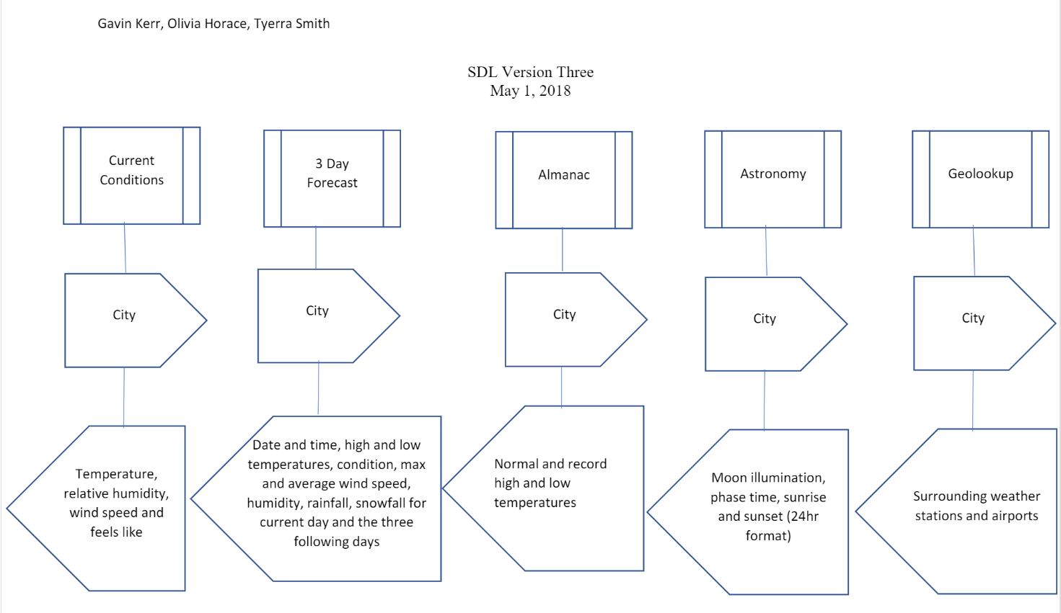

5.2 Appendix II:

